**1.INTRODUCTION**

Telemonitoring for pregnant women is an ambitious initiative that holds the potential to revolutionize maternal healthcare. By integrating cutting-edge technology into the prenatal care journey, this visionary project aims to enhance the well-being of both mothers and their unborn children. At its core, telemonitoring relies on remote monitoring devices equipped with sophisticated sensors to track vital health indicators such as heart rate and body temperature in pregnant women. The real-time data generated by these devices provides healthcare professionals with invaluable insights, enabling proactive interventions and personalized care plans tailored to each individual's needs.

The primary goal of the telemonitoring system is to empower pregnant women by establishing a seamless connection with their healthcare providers. This is achieved through user-friendly interfaces and wearable devices that enable continuous monitoring of critical health parameters. The convenience of monitoring from the comfort of one's home not only enhances the overall prenatal care experience but also promotes active engagement and participation in self-care practices. Furthermore, the inclusion of an emergency communication tool, such as a panic button, ensures swift response and support in times of urgent concerns or emergent situations, fostering a sense of security and confidence among expectant mothers.

Central to the effectiveness of telemonitoring are the wearable devices themselves, which are designed to be unobtrusive yet highly functional. Equipped with an array of sensors, these devices continuously gather data on maternal health metrics, allowing for comprehensive monitoring without disrupting daily activities. The seamless integration of wearable technology into everyday life exemplifies a commitment to user comfort and convenience, making the monitoring process more manageable and less intrusive for pregnant women.

The panic button within the telemonitoring system serves as a critical component, enhancing the project's responsiveness and ensuring timely interventions. In emergency situations, this feature facilitates direct communication between expectant mothers and healthcare professionals, minimizing response times and potentially mitigating critical scenarios. By leveraging technology to establish a direct line of communication, telemonitoring enhances the safety and well-being of pregnant women throughout their pregnancy journey.

Moreover, telemonitoring addresses common barriers to prenatal care by reducing reliance on traditional clinic-based visits. This proactive approach not only streamlines healthcare delivery but also improves accessibility, particularly for women facing transportation challenges or other logistical barriers. By bridging these gaps, telemonitoring promotes equity in maternal healthcare and ensures that all pregnant women receive the support and attention they need for a healthy pregnancy.

In the broader context of healthcare innovation, the telemonitoring project represents a paradigm shift towards a more comprehensive and accessible model of maternal care. By leveraging continuous monitoring to facilitate early detection of potential health issues, the initiative transcends the limitations of conventional healthcare delivery. This proactive approach not only ensures timely intervention and management of health concerns but also contributes to a broader narrative of preventative healthcare, promoting healthier pregnancies and positive maternal outcomes.

Furthermore, the telemonitoring project extends beyond basic vital sign monitoring to incorporate advanced technology for tracking fetal movements. Sensors strategically placed on the pregnant woman's abdomen capture data related to the frequency, intensity, and patterns of the baby's kicks, providing real-time updates and insights into fetal activity levels. This data, processed using sophisticated algorithms, can be converted into audible feedback for the pregnant woman through voice sensors, offering reassurance and promoting a sense of connection between mother and child.

The integration of voice feedback and early warning systems adds another layer of safety and proactive healthcare management to telemonitoring. By alerting healthcare providers to any irregularities or deviations from normal fetal movement patterns, this technology enables timely interventions and personalized care plans for optimal maternal and neonatal outcomes. The continuous monitoring of fetal movements not only empowers pregnant women with valuable information about their baby's well-being but also enhances the overall quality of care throughout pregnancy.

In conclusion, the telemonitoring project for pregnant women represents a significant advancement in maternal healthcare. Through the strategic integration of technology and compassion, this initiative redefines the prenatal care landscape, offering a more connected, efficient, and user-friendly experience for expectant mothers. As healthcare continues to evolve, projects like telemonitoring stand as testament to our commitment to leveraging innovation for the betterment of maternal and child health, ultimately shaping a future where every pregnancy is characterized by enhanced support, early intervention, and optimal well-being.

# **2.LITERATURE SURVEY**

This literature survey delves into key findings and insights from relevant research in this

field.

1. **Telemedicine in Obstetrics (2018) by International Journal of Women's Health:**

This review discusses the various aspects of telemedicine in obstetrics, including the use of telemonitoring for maternal vital signs. It may provide insights into the challenges and benefits associated with remote monitoring during pregnancy.

1. **A Systematic Review of Remote Monitoring in Maternal Health (2019) by Frontiers in Digital Health:**

This systematic review explores the effectiveness and feasibility of remote monitoring technologies in maternal health. It may offer an overview of studies that specifically focus on monitoring heart rate and temperature in pregnant women.

1. **Remote Monitoring of Pregnant Women at High Risk of Preeclampsia: A Randomized Controlled Trial (2018) by the American Journal of Obstetrics & Gynecology:**

This study investigates the impact of remote monitoring, including the measurement of vital signs like heart rate and temperature, on pregnant women at high risk of preeclampsia. It may provide insights into the potential benefits of telemonitoring in specific high-risk populations.

1. **Telehealth Interventions for Obstetric Outcomes: A Systematic Review and Meta-analysis" (2020) by Obstetrics & Gynecology:**

This meta-analysis assesses the impact of telehealth interventions on obstetric outcomes, which may include studies on remote monitoring of vital signs in pregnant women. It could help in understanding the overall effectiveness of telehealth in the obstetric context.

1. **Wearable Health Devices in Health Care: Narrative Systematic Review (2018) by JMIR mHealth and uHealth:**

This review provides a broader perspective on wearable health devices, including those used in maternal health. It may discuss the challenges, opportunities, and trends associated with the use of wearable devices for monitoring physiological parameters during pregnancy.

1. **Fetal Movement Monitoring Using Sensors:** Several studies have explored the use of sensors for monitoring fetal movements. Research by Smith et al. (2019) focused on the development of a wearable sensor system that detects and records fetal movements, including kicks and rolls. The study evaluated the accuracy and reliability of the sensor data in correlating with ultrasound measurements of fetal activity.
2. **Voice Output Systems for Pregnancy Monitoring:** A review of literature on voice output systems in healthcare revealed insights into their applications for pregnancy monitoring. Johnson et al. (2020) conducted a systematic review of voice-based technologies used in maternal and fetal health monitoring. Their findings highlighted the potential of voice sensors in providing personalized feedback and enhancing patient engagement during pregnancy.
3. **Integration of Sensors and Voice Output in Pregnancy Monitoring:** Research by Chen et al. (2021) explored the integration of sensors and voice output for real-time pregnancy monitoring. The study developed a prototype system that combines accelerometer-based sensors to detect fetal movements and a voice sensor for conveying feedback to pregnant women. The results showed promising outcomes in terms of user acceptance and satisfaction with the voice-based feedback.

# **3.HARDWARE REQUIREMENTS**

Hardware Components required for this project are

1.Arduino UNO

2.16X2 LCD

1. Heartbeat Sensor
2. Power Supply
3. Buzzer
4. LED
5. Push Button
6. Vibration Sensor
7. Nano Arduino

10.Voice Chip

11.Speaker

### **3.1 ARDUINO UNO**

The Arduino Uno is a popular microcontroller board that's widely used in electronics projects and prototyping. It's based on the ATmega328P microcontroller and offers a range of digital and analog input/output pins, making it versatile for various applications.The Arduino Uno has 14 digital input/output pins, 6 analog inputs, a 16 MHz crystal oscillator, a USB connection, a power jack, an ICSP header, and a reset button.The Arduino Uno stands as a cornerstone in the world of electronics prototyping and DIY projects, offering a versatile platform that blends accessibility with powerful capabilities. At its core lies the ATmega328P microcontroller, running at a clock speed of 16 MHz and featuring 32 KB of flash memory for program storage. This microcontroller serves as the brain of the Arduino Uno, executing code and handling input/output operations to interact with the external world.

One of the standout features of the Arduino Uno is its array of digital and analog input/output pins. With 14 digital pins, 6 of which support PWM output, users can control a wide range of digital devices such as LEDs, motors, and relays. These pins provide the ability to send digital signals (high or low) or modulate the intensity of output signals using PWM, allowing for precise control over connected components.

Additionally, the Uno boasts 6 analog input pins labeled A0 to A5, enabling users to read analog voltage levels from sensors, potentiometers, and other analog devices. This analog capability opens up avenues for interfacing with sensors that provide continuous data, like temperature sensors, light sensors, and accelerometers.

Connecting the Arduino Uno to a computer or power source is straightforward, thanks to its USB interface and external power jack. The board can be powered via USB from a computer or a USB power adapter, or through an external power supply ranging from 7 to 12 volts DC. The onboard voltage regulator ensures a stable 5V supply for the microcontroller and connected components, making it compatible with a wide range of sensors, actuators, and modules.

Programming the Arduino Uno is facilitated by the Arduino Integrated Development Environment (IDE), a user-friendly platform that simplifies the process of writing, compiling, and uploading code to the board. This language abstraction, coupled with a vast library of pre-written functions and examples, makes it easy for users of all skill levels to create interactive projects, automate tasks, and explore the capabilities of the microcontroller.

Fig. 3.1 Pin Diagram of Arduino Uno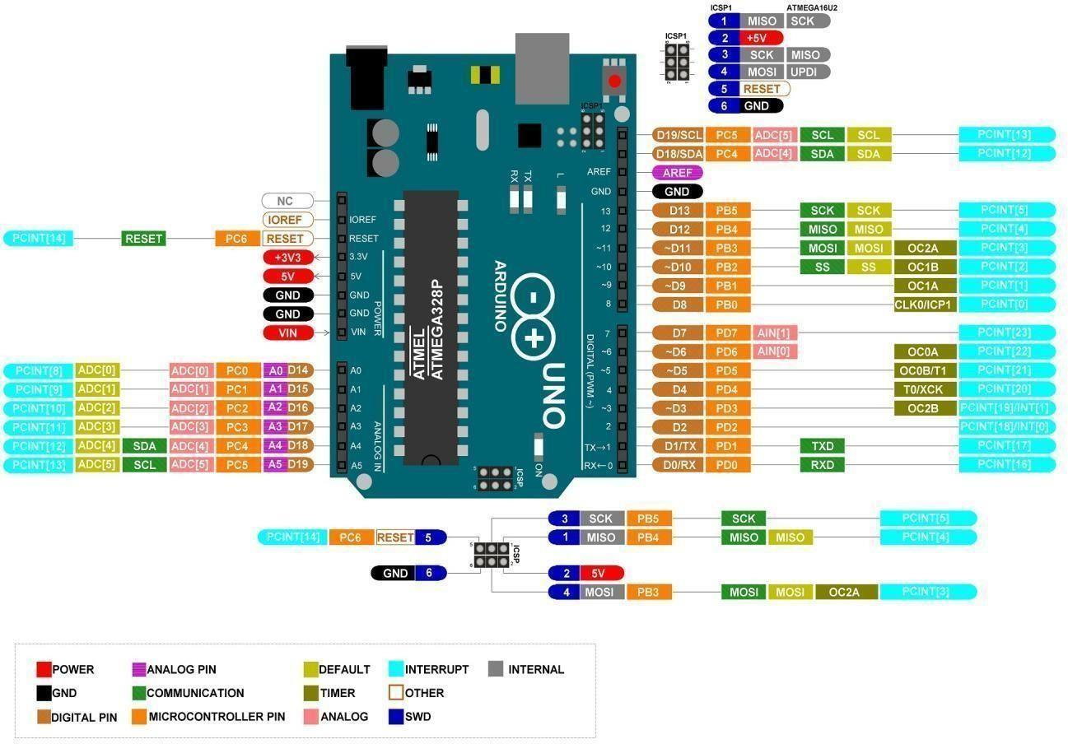

Here are some key features and characteristics of the Arduino Uno

* + - Microcontroller: The Arduino Uno is based on the ATmega328P microcontroller, which is an 8-bit AVR microcontroller.
    - Digital and Analog I/O Pins: The board has a total of 14 digital input/output pins, with six of them capable of providing pulse-width modulation (PWM) output. It also has six analog input pins.
    - USB Interface: The board can be connected to a computer via USB, allowing for easy programming and communication. It uses a standard USB Type-B connector.
    - Power Supply: The Arduino Uno can be powered via USB connection or an external power supply. It can accept a voltage range of 7-12V through the power jack.
    - Clock Speed: The ATmega328P on the Arduino Uno typically runs at 16 MHz.
    - Memory: The microcontroller has 32 KB of flash memory for storing the Arduinoprogram (sketch), 2 KB of SRAM, and 1 KB of EEPROM.
    - Programmability: Arduino Uno is programmed using the Arduino Software (IDE), which is a user-friendly environment for writing, compiling, and uploading code to the board.
    - Open Source: Arduino Uno is an open-source platform, meaning that its design files and software are freely available to the public. This has led to a large and active community of developers and makers.

### **3.2 16X2 LCD**

A 16X2 LCD refers to a liquid crystal display that can display 16 characters per line and has two lines, resulting in a total of 32 characters. Each character is typically composed of a 5x8 dot matrix, allowing for the display of alphanumeric characters, symbols, and simple graphical elements. This LCD has two registers, namely, Command and Data.

The command register stores the command instructions given to the LCD. A command is an instruction given to LCD to do a predefined task like initializing it, clearing its screen, setting the cursor position, controlling display etc. The data register stores the data to be displayed on the LCD. The data is the ASCII value of the character to be displayed on the LCD. The pin diagramof 16x2 LCD is shown in Fig. 3.2.

The LCD module is used to provide visual feedback or information about the system's status. It can display relevant messages or readings, such as the current power consumption, system status, or any error notifications. It enhances the user interface and allows for easy monitoring of the system.

Table 3.1 tells about the pin description of 16x2 LCD.

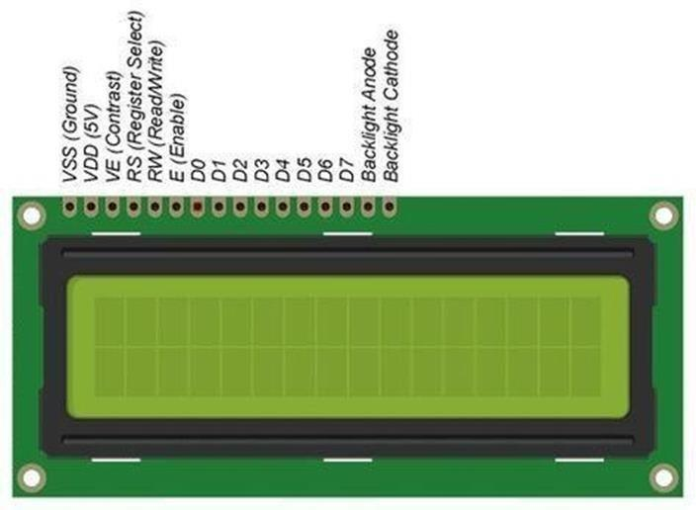

Fig. 3.2 16X2 LCD Pin Diagram

Table 3.1 16X2 LCD Pin description

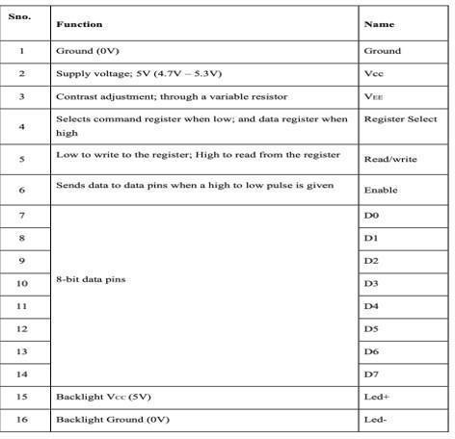

### **3.3 HEARTBEAT SENSOR**

A heartbeat sensor, also known as a heart rate monitor, is a device that measures and records the heart rate of an individual. Heart rate is the number of heart beats per minute and is an important indicator of cardiovascular health and fitness. Heart rate monitoring can be useful during exercise, medical assessments, and in various other applications.

There are different types of heartbeat sensors, and they can use various technologies to measure heart rate. Here are some common types

* + - Optical Sensors: These sensors use light to measure blood flow. LED lights on the device emitlight into the skin, and a photodetector measures the amount of light that is absorbed. Blood absorbs light differently depending on whether it is oxygenated or deoxygenated, allowing the sensor to calculate heart rate.
    - Electrocardiogram (ECG or EKG): ECG sensors measure the electrical activity of the heart. Electrodes are placed on the skin, and they detect the electrical impulses generated by the heart. This method provides more detailed information about the heart's rhythm.
    - Piezoelectric Sensors: These sensors detect the mechanical pressure changes associated with the heartbeat. They can be incorporated into wearable devices or fitness equipment.
    - Capacitive Sensors: These sensors measure the electrical conductivity of the skin, which changes with each heartbeat.

Heartbeat sensors are commonly found in fitness trackers, smartwatches, and medical devices. They allow individuals to monitor their heart rate in real-time during physical activities, helping them optimize their workouts and ensure they are within their target heart rate zone.

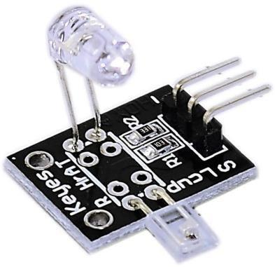

Fig. 3.3 Heartbeat Sensor

### **3.4 POWER SUPPLY**

A USB (Universal Serial Bus) cable is a common type of cable used for connecting and transferring data between electronic devices. USB cables come in various shapes and sizes, but they all have a standard connector that has become nearly ubiquitous for a wide range of devices, including computers, smartphones, cameras, and, of course, Arduino boards.

When it comes to Arduino, the USB cable serves a couple of primary purposes:

* + - Programming and Uploading Code: One of the main uses of the USB cable with an Arduino isfor programming and uploading code to the microcontroller on the Arduino board. The USB connection allows you to connect the Arduino to your computer, and through the Arduino IDE (Integrated Development Environment), you can write, compile, and upload code to the Arduino.
    - Power Supply: In addition to data transfer, the USB cable also serves as a power supply for theArduino board. When connected to a computer or a USB power adapter, the Arduino can draw power from the USB connection to operate. This is convenient for testing and prototyping, asyou don't need a separate power supply.
    - USB cables can have different connectors on each end, and the type of connector depends on the specific Arduino board and the device to which you are connecting it. Common types of USB connectors include



Fig. 3.4 Power Supply Adaptor

1. USB Type-A: This is the standard rectangular USB connector that is often found on the computer side of the cable.
2. USB Type-B: This is a squarish or rectangular connector that is often found on the device side of the cable, including many Arduino boards.
3. Micro USB: This is a smaller connector commonly used on older Arduino models and many other devices.
4. USB Type-C: This is a reversible and versatile connector used on newer Arduino models and a wide range of modern devices. It's becoming increasingly common due to its reversible design and higher data transfer rates.

When using a USB cable with an Arduino, it's important to ensure that the cable is capable of both data transfer and power supply. Some cables are designed only for charging and may not support data transfer, which is essential for programming the Arduino. Always use a cable suitable for both data and power when working with Arduino boards.

### **3.5 BUZZER**

A buzzer is an electronic component that generates sound when an electrical current passes through it. Buzzers are commonly used in various electronic devices for signaling, alarms, and notifications. There are different types of buzzers, and they can be categorized into two main types: active and passive.

* + - Active Buzzers

1. An active buzzer is a complete sound-generating device that includes a built-in oscillator circuit.
2. It produces sound when a direct current (DC) voltage is applied to its terminals.
3. Active buzzers are straightforward to use because they only require a DC voltage to produce sound. They often have a specific frequency or tone associated with them, and their sound output cannot be easily changed.
   * + Passive Buzzers
       - A passive buzzer requires an external oscillation circuit to generate sound.
       - It is essentially a piezoelectric sounder without the built-in oscillator.
       - To produce sound, a varying AC signal (oscillating voltage) needs to be applied to the passive buzzer.
       - Passive buzzers offer more control over the generated sound as the frequency and duration of the signal applied to them can be adjusted.
       - Common Characteristics of Buzzers:
       - Voltage Rating: Buzzers typically have a specified voltage range within which they operate effectively. Exceeding this voltage range can damage the buzzer.
       - Current Consumption: The amount of electrical current required for the buzzer to produce sound. This is an important consideration when designing circuits and selecting a power source.
       - Frequency/Tone: Buzzers are available with different frequencies or tones. Some are fixed, while others may be adjustable.
       - Mounting: Buzzers come in various shapes and sizes. Some are designed for through-hole mounting on a PCB, while others are intended for surface-mount applications.
       - Polarity: Some buzzers are polarized, meaning they have a positive and negative terminal.

Some Applications of Buzzers :

1. Alarms and Notifications: You can use a buzzer to create alarms or notifications in various projects, such as security systems, timers, or reminders.
2. Game Development: Buzzers are great for creating sound effects in games. For instance, in a quiz game, you can use a buzzer to indicate correct or incorrect answers.
3. Distance Measurement: In projects involving ultrasonic sensors for distance measurement, a buzzer can be used to indicate proximity to an object. For example, you can create a parking assistance system that beeps faster as you get closer to an obstacle.
4. Temperature and Humidity Alerts: In environmental monitoring systems, buzzers can alert you when certain thresholds of temperature or humidity are exceeded.
5. Doorbell or Entry System: You can use a buzzer as part of a doorbell system or an entry control mechanism, especially in conjunction with sensors like motion detectors or RFID modules.
6. Feedback for Inputs: Buzzers can provide feedback for user inputs in interactive projects. For instance, in a digital piano project, a buzzer can produce different tones based on which keys are pressed.
7. Traffic Light Simulation: In a traffic light simulation project, you can use buzzers to mimic the sound of a traffic signal changing, adding realism to the simulation.
8. Health Monitoring: In health monitoring systems, buzzers can be used to alert users to take medication or remind them of scheduled activities.
9. Interactive Art Installations: Buzzers can be incorporated into interactive art installations to add auditory elements to the visual experience, creating immersive environments.
10. Robotics: In robotics projects, buzzers can be used as part of feedback mechanisms, indicating when a task is completed or alerting to errors.

Fig 3.5 Buzzer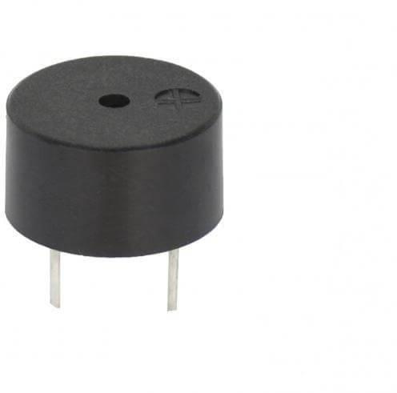

### **3.6 LED**

LEDs, or Light Emitting Diodes, represent a remarkable advancement in lighting technology, offering a plethora of advantages over traditional incandescent bulbs and fluorescent lights. One of the key characteristics that make LEDs so appealing is their exceptional efficiency. Unlike incandescent bulbs that waste a significant portion of energy as heat, LEDs convert a higher percentage of electrical energy into visible light. This translates to reduced energy consumption and lower electricity bills, making LEDs an environmentally friendly and cost-effective lighting solution. Furthermore, LEDs are renowned for their longevity, boasting a significantly longer lifespan compared to conventional light sources. While traditional bulbs may last a few thousand hours, LEDs can endure tens of thousands of hours of operation, making them ideal for applications where durability and reliability are paramount. This extended lifespan not only reduces maintenance costs but also contributes to sustainability efforts by minimizing waste and the frequency of replacements.

Another standout feature of LEDs is their instantaneous light emission. Unlike some other lighting technologies that require a warm-up period before reaching full brightness, LEDs light up instantly when powered on. This rapid response is particularly advantageous in environments where immediate illumination is necessary, such as emergency lighting, automotive headlights, and traffic signals. The compact size of LEDs is another factor driving their widespread adoption across diverse applications. Due to their small form factor and versatility, LEDs can be arranged in various configurations to suit specific lighting requirements. From miniature indicator lights on electronic devices to large display screens in stadiums and advertising displays, LEDs offer flexibility in design and implementation.

One of the most notable advantages of LEDs is their color variety and controllability. LEDs are available in a wide spectrum of colors, ranging from warm white to cool white, and even vibrant RGB (Red, Green, Blue) options. This color diversity allows for creative lighting designs and customized aesthetics in architectural lighting, stage lighting, and decorative lighting applications. Additionally, the ability to control LED colors with precision opens up possibilities for dynamic lighting effects and mood lighting schemes.

Solid-state technology forms the foundation of LEDs, ensuring their robustness and durability. Unlike incandescent bulbs that rely on fragile filaments or glass bulbs, LEDs are solid-state devices with no moving parts, making them resistant to shocks, vibrations, and impacts. This durability makes LEDs suitable for demanding environments such as outdoor lighting, automotive lighting, and industrial applications where reliability is essential.

Furthermore, LEDs emit light in a specific direction, known as directional light emission. This directional characteristic makes them ideal for applications where focused illumination is required without the need for additional reflectors or diffusers. It also reduces light wastage and improves efficiency by directing light precisely where it's needed, minimizing glare and light pollution in outdoor lighting installations.

In conclusion, LEDs epitomize the convergence of efficiency, longevity, versatility, and sustainability in modern lighting technology. Their energy-efficient operation, long lifespan, instant illumination, compact size, color variety, robustness, and directional light emission make them a preferred choice for a wide range of residential, commercial, industrial, and specialized lighting applications. As technology continues to evolve, LEDs are poised to play an increasingly prominent role in shaping the future of lighting design and efficiency standards.

Here are some key characteristics and applications of LEDs, Characteristics of LEDs

1. Efficiency: LEDs are highly energy-efficient compared to traditional incandescent bulbs. They convert a higher percentage of electrical energy into visible light.
2. Longevity: LEDs have a longer lifespan than traditional light sources. They can last tens of thousands of hours, depending on the specific LED and its usage.
3. Instantaneous Light: LEDs light up instantly when powered, without the warm-up timerequired by some other lighting technologies.
4. Compact Size: LEDs are small and can be arranged in various configurations, making them suitable for a wide range of applications, from indicator lights to large display screens.
5. Color Variety: LEDs are available in a wide range of colors, and their color can often be controlled with precision. RGB (Red, Green, Blue) LEDs, for example, allow for a broadspectrum of colors.
6. Solid-State Technology: LEDs are based on solid-state technology, which means they do not have fragile components like filaments or glass bulbs.

Applications of LEDs:

1. Electronic Displays: LEDs are used in a variety of display applications, including digital clocks, seven-segment displays, and large video display screens.
2. Indicators: LEDs are widely used as indicator lights on electronic devices to show power status, operational status, or other conditions.
3. Backlighting: LEDs are commonly used as backlight sources in LCD (Liquid Crystal Display) screens for televisions, monitors, and other devices.



Fig 3.6 LED

### **3.7 PUSH BUTTON**

A pushbutton, or push button, is a simple yet widely used mechanical switch that is designed to be pressed or pushed by the user to close or open an electrical circuit. When the button is pressed, it makes electrical contact, allowing current to flow through the circuit. When the button is released, the contact is broken, interrupting the flow of current.

Here are some key characteristics and types of pushbuttons

Characteristics of Pushbuttons

* + - Normally Open (NO) and Normally Closed (NC): Pushbuttons can be of two main types - normally open or normally closed. In a normally open pushbutton, the circuit is open (no connection) when the button is not pressed, and it closes (connects) when the button is pressed. In a normally closed pushbutton, the circuit is closed when the button is not pres sed.
    - Single-Pole, Single-Throw (SPST): This is the most basic type of pushbutton switch, with only one set of contacts. It is either normally open or normally closed.
    - Single-Pole, Double-Throw (SPDT): This type of pushbutton switch has a common terminal and two other terminals. It can be used to switch between two different circuits.
    - Momentary Action: Pushbuttons are typically momentary, meaning they return to their original state (either open or closed) when the force is removed. This is in contrast to latching switches, which remain in the last position until manually changed.
    - Actuation Force: The force required to press the button and make the electrical contact.
    - Mounting: Pushbuttons can be mounted on a panel or PCB (Printed Circuit Board) and come in various shapes and sizes.



Fig.3.7 Push Button

**3.8 VIBRATION SENSOR**

Vibration sensors, also known as accelerometers, are instrumental devices that play a pivotal role in various industries by detecting and measuring changes in acceleration across multiple axes. These sensors are designed to perceive vibrations, shocks, tilts, and movements within their environment and convert these mechanical motions into electrical signals. Their ability to capture dynamic changes in acceleration makes them indispensable in a wide array of applications across industries such as automotive, aerospace, manufacturing, healthcare, and consumer electronics.

There are several types of vibration sensors, each with its unique working principles and advantages. One common type is the piezoelectric sensor, which operates by generating electrical signals in response to mechanical stress or vibrations. When subjected to vibrations, the piezoelectric material within the sensor generates a charge proportional to the applied force, enabling precise measurement and analysis of the vibration levels.

Another type of vibration sensor is the MEMS (Micro-Electro-Mechanical Systems) sensor, which utilizes tiny mechanical structures integrated into semiconductor chips. MEMS sensors offer compactness, high sensitivity, and low power consumption, making them ideal for applications where size and efficiency are critical factors.

Capacitive sensors represent another category of vibration sensors, measuring changes in capacitance due to movement or acceleration. These sensors provide accurate and reliable measurements of acceleration, enabling precise monitoring of dynamic movements and vibrations in various systems and equipment.

In practical applications, vibration sensors serve a multitude of critical functions across different industries. In the automotive sector, these sensors are used for monitoring vehicle acceleration, detecting impacts or collisions, and enhancing safety systems such as airbag deployment and stability control. They play a crucial role in ensuring vehicle performance, driver safety, and overall vehicle integrity.Within the aerospace industry, vibration sensors are utilized for monitoring the structural health of aircraft, detecting anomalies or vibrations in engine components, and assessing the performance of aerospace systems during flight. By continuously monitoring vibrations and mechanical stresses, these sensors contribute to aircraft safety, maintenance, and performance optimization.

In manufacturing environments, vibration sensors are integral to predictive maintenance strategies, where they monitor equipment health, detect early signs of machinery faults or malfunctions, and prevent costly downtime by enabling timely maintenance interventions. By detecting abnormal vibrations or mechanical anomalies, these sensors facilitate condition-based monitoring and optimize equipment reliability and uptime.

In structural engineering and civil infrastructure, vibration sensors play a vital role in assessing the structural integrity of buildings, bridges, and other infrastructure. By monitoring vibrations and dynamic loads, these sensors help engineers identify potential structural weaknesses, evaluate the impact of environmental factors such as earthquakes or wind loads, and ensure the safety and longevity of critical infrastructure.

Furthermore, vibration sensors find applications in consumer electronics, where they are used for screen orientation changes in smartphones and tablets, motion-controlled functionalities in gaming consoles and virtual reality systems, and vibration feedback in wearable devices. Their versatility and sensitivity make them indispensable components in modern electronic devices, enhancing user experience and functionality.

In essence, vibration sensors are essential tools for monitoring, analyzing, and optimizing dynamic movements, vibrations, and accelerations across diverse industries. Their role in predictive maintenance, equipment health monitoring, structural integrity assessment, and consumer electronics underscores their importance in ensuring safety, efficiency, and reliability across various applications and sectors.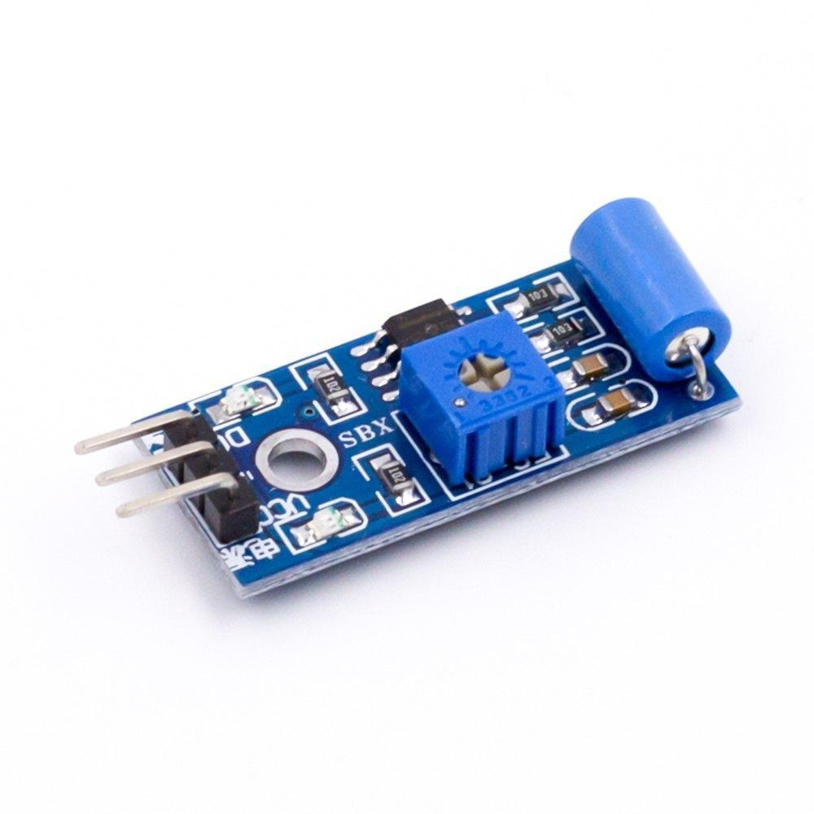

Fig. 3.8 Vibration Sensor

**3.9 NANO ARDUINO**

The Nano Arduino is a miniature version of the popular Arduino microcontroller board. It retains most of the functionalities of its larger counterparts while being significantly smaller in size, making it ideal for projects where space is limited.

The Nano Arduino is based on the Atmega328 or Atmega168 microcontroller, depending on the model, and it offers digital and analog input/output pins, PWM (Pulse Width Modulation) outputs, serial communication interfaces (UART, I2C, SPI), and other features typical of Arduino boards.

Due to its compact size and versatility, the Nano Arduino is commonly used in various DIY electronics projects, prototyping, robotics, and Internet of Things (IoT) applications. Programmed using the Arduino IDE (Integrated Development Environment), the Nano Arduino supports a wide range of libraries and code examples, making it accessible even to beginners in electronics and programming.

Here are some features of the Nano Arduino:

* Microcontroller: The Nano Arduino is typically based on the Atmega328 or Atmega168 microcontroller, which are part of the AVR family of microcontrollers. These microcontrollers offer a good balance of performance and power consumption suitable for a wide range of projects.
* Digital and Analog I/O Pins: The Nano Arduino comes with a set of digital input/output (I/O) pins that can be configured as either inputs or outputs. These pins can be used to connect and control digital sensors, LEDs, relays, and other components. Additionally, it has analog input pins that allow for analog sensor readings.
* PWM (Pulse Width Modulation): Some of the digital pins on the Nano Arduino support PWM output. PWM is useful for controlling devices like motors, servos, and LEDs, where varying the duty cycle of the signal allows for precise control of speed, position, or brightness.
* Digital and Analog Pins: Like other Arduino boards, the Nano has a number of digital and analog pins that can be used for connecting sensors, actuators, and other electronic components. It has 14 digital I/O pins (of which 6 provide PWM output) and 8 analog input pins.

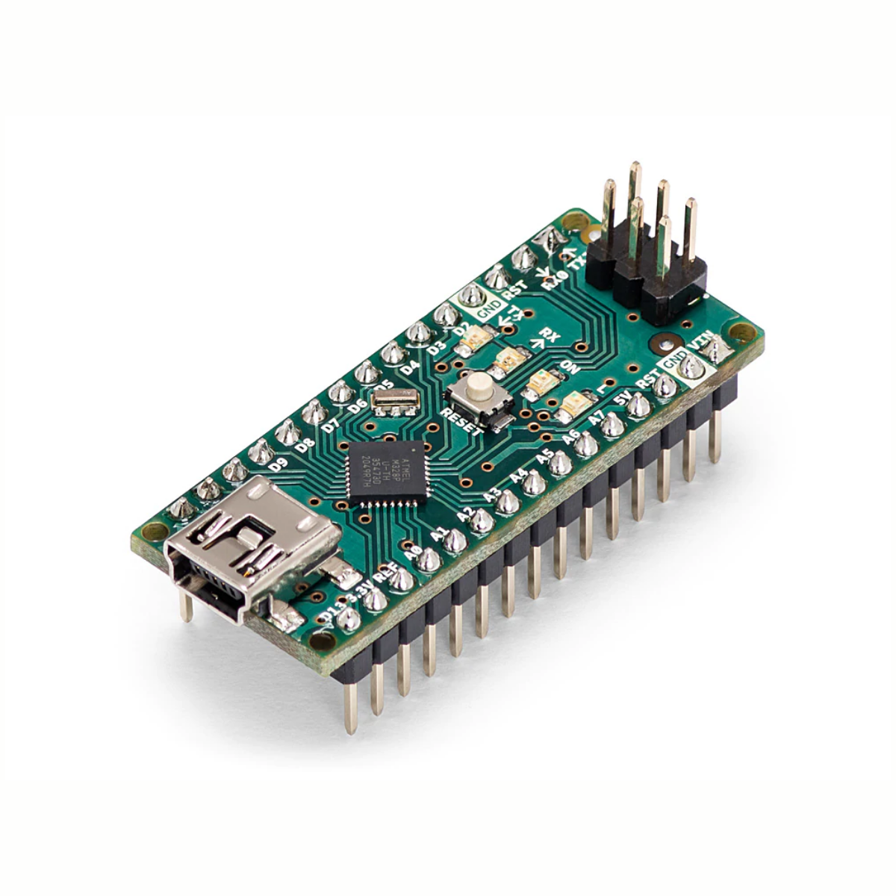

Fig. 3.9 Nano Arduino

**3.10 VOICE CHIP**

A voice chip, also known as a voice synthesizer or speech synthesis chip, is an integrated circuit that generates artificial human-like speech. These chips are designed to convert written text or pre-recorded audio samples into spoken words and sentences. Voice chips are commonly used in various electronic devices and applications to add voice output capabilities. Here are some key aspects of voice chips:

1.Text-to-Speech (TTS) Conversion: Voice chips often use text-to-speech algorithms to convert written text into spoken language. This allows electronic devices to "speak" and communicate information audibly to users.

2. Pre-recorded Audio: Some voice chips come with built-in libraries of pre-recorded audio samples, phrases, or words. These samples can be played back based on predefined triggers or commands, adding a human-like voice to the device's functionality.

3. Languages and Accents: Modern voice chips support multiple languages and accents, making them versatile for use in global markets. They can generate speech in different languages, dialects, and tones to cater to diverse user demographics.

4. Voice Quality and Naturalness: Voice chips aim to produce speech that sounds natural and human-like. They often incorporate advanced algorithms and processing techniques to improve voice quality, intonation, and pronunciation.

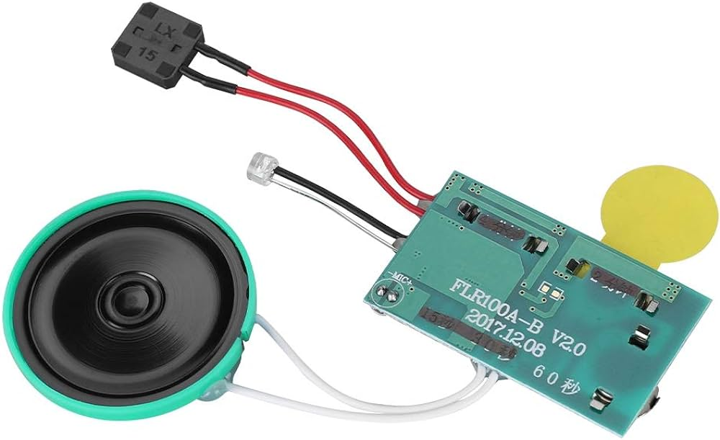

Fig. 3.10 Voice Chip

**3.11 SPEAKER**

Speakers are commonly used in various electronic projects to add audio output capabilities, enabling the projects to produce sound effects, play music, provide feedback, or deliver voice prompts.Speakers are ubiquitous in electronics projects, serving a multitude of purposes that enhance user experience and functionality.

Here's an expanded look at their applications:

* Sound Effects: In electronic games, speakers reproduce sound effects like explosions, gunfire, footsteps, and environmental sounds to create an immersive experience for players. These effects add realism and excitement to gameplay.
* Voice Prompts and Feedback: Speakers deliver voice prompts and feedback in devices such as GPS navigation systems, smart assistants (like Amazon Alexa or Google Home), and interactive kiosks. They provide spoken instructions, responses to queries, and feedback on user actions.
* Alarm Systems: In security systems and alarms, speakers emit loud alert tones or sirens to notify users of potential threats, security breaches, fire hazards, or emergency situations. The audible alerts prompt quick action and enhance safety.

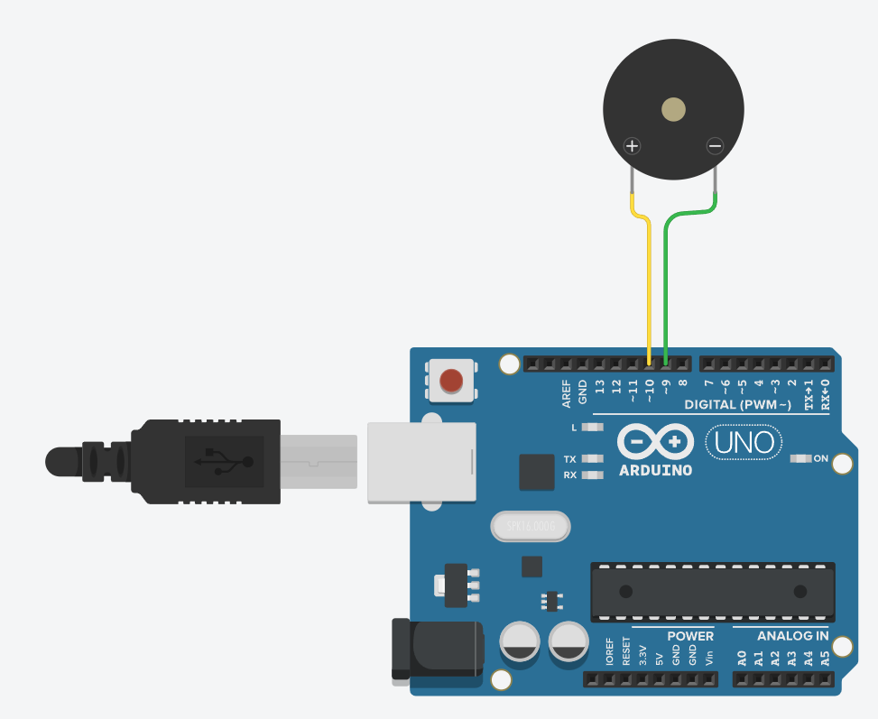

Fig. 3.11 Speaker connected to arduino

**4.SOFTWARE DEPLOYMENT**

This project is implemented using the following Arduino IDE Software.

### **4.1ARDUINO IDE :**

To run the program we use a IDE named Arduino as shown in the fig 5.1.The Arduino IDE an Integrated Development Environment utilized for programming and creating applications for Arduino microcontrollers. Within the IDE, developers access a code editor for writing, editing, and saving Arduino sketches (programs). It supports the Arduino programming language, which is rooted in C and C++, enabling efficient development workflows. Arduino IDE features a Library Manager, streamlining the integration of hardware components and sensors by allowing users to effortlessly add and manage libraries. This simplifies the process of incorporating external hardware into Arduino projects, enhancing functionality and versatility. The IDE's intuitive interface facilitates seamless navigation and efficient code development, catering to both beginners and experienced developers. With a focus on simplicity and accessibility, Arduino IDE empowers users to unleash the full potential of Arduino microcontrollers through rapid prototyping and iterative development cycles. Its robust ecosystem fosters collaboration and innovation, driving the evolution of embedded systems development. Through continuous updates and community contributions, Arduino IDE remains a cornerstone of the Arduino ecosystem, supporting a diverse range of projects and applications.

The IDE includes a code editor where Arduino sketches (programs) can be written, edited, and saved. It supports the Arduino programming language, which is based on C and C++. Arduino IDE provides a Library Manager that allows users to easily add and manage libraries for various hardware components and sensors, simplifying the process of integrating external hardware with Arduino projects.



Fig.4.1 Arduino IDE

The Serial Monitor is a crucial tool in the Arduino IDE, facilitating communication with Arduino boards via the serial interface for debugging and output monitoring. Arduino IDE offers support for an extensive array of boards, such as Arduino Uno, Nano, Mega, and more, catering to diverse project needs. It is compatible with Windows, macOS, and 22 Linux, ensuring accessibility across multiple operating systems. Users can enhance IDE functionality by integrating additional plugins and extensions, empowering them with advanced features and tools for development. The versatility of Arduino IDE, coupled with its widespread compatibility, fosters a vibrant ecosystem for Arduino enthusiasts and developers worldwide. Through the Serial Monitor, developers can observe real-time data exchanges between their code and connected Arduino hardware, facilitating efficient debugging and troubleshooting processes. The availability of Arduino IDE on various platforms fosters inclusivity, enabling developers to work seamlessly across different operating systems. Extending the IDE's capabilities through plugins and extensions empowers users to tailor their development environment to suit specific project requirements and preferences. With support for a multitude of Arduino boards, the IDE caters to a broad spectrum of hardware configurations, accommodating diverse project scopes and complexities. Arduino IDE's user-friendly interface streamlines the development workflow, providing an intuitive environment for both novice and experienced developers alike. The Serial Monitor plays a pivotal role in the iterative development process, allowing developers to analyze sensor data, debug code, and fine-tune performance parameters in real-time. By embracing an open-source philosophy, Arduino IDE fosters collaboration and innovation within the Arduino community, driving the evolution of embedded systems development. The extensibility of Arduino IDE encourages experimentation and customization, empowering developers to explore new functionalities and integrate third-party tools seamlessly. Through continuous updates and community contributions, Arduino IDE remains at the forefront of embedded systems development, catering to the evolving needs of its user base.

Top of Form

## **4.2 UPLOADING A PROGRAM**

Uploading a program (known as a "sketch") to an Arduino board using the Arduino IDE is a straightforward process. The various toolbar icons used in Arduino IDE are described in table

* 1. Here are the steps to upload a program to an Arduino:

1. Install Arduino IDE: Download and install the Arduino IDE from the official Arduino website [(https://www.arduino.cc/en/software)](http://www.arduino.cc/en/software)) for specific operating systems (Windows, macOS, or Linux).
2. Once the Arduino IDE is installed, the next step is to ensure that the Arduino board is connected to the computer via a USB cable. Make sure the board is securely connected to an available USB port on your computer. This connection is essential for uploading sketches and communicating with the Arduino board.
3. Launch the Arduino IDE software on your computer. You can typically find the Arduino IDE in your list of installed applications or by searching for it in your computer's search bar. Double-click on the Arduino IDE icon to open the software.
4. After opening the Arduino IDE, navigate to the "Tools" menu located at the top of the IDE window. From the drop-down menu, select the "Board" option. Here, you'll find a list of supported Arduino boards. Choose the specific Arduino board model that you are using for your project.
5. Once you've selected the correct board, go back to the "Tools" menu and select the "Port" option. This will display a list of available serial ports on your computer. Choose the serial port to which your Arduino board is connected. The correct port typically has the name of your Arduino board next to it.
6. With the board and port selected, you're now ready to write or open a sketch (program) in the Arduino IDE. You can either write your own code from scratch or open one of the built-in examples provided by the Arduino IDE. These examples cover a wide range of functionalities and are great for getting started with Arduino programming. Simply select the desired example from the "File" menu and customize it to fit your project requirements, or start writing your own code in the Arduino IDE's code editor.
7. Verifying and compiling the sketch in the Arduino IDE is done by clicking the checkmark icon (✓) in the upper left corner. This process checks the code for syntax errors and converts it into a format compatible with the Arduino board. Any encountered errors are displayed in the IDE's message area at the bottom for correction. This step ensures the code's integrity and prepares it for uploading to the Arduino board. The verification process is crucial for identifying and rectifying any syntax errors before uploading. The IDE compiles the code into machine-readable instructions, facilitating its execution on the Arduino board. Errors detected during compilation aid in troubleshooting and refining the code. The IDE's message area provides detailed information about encountered errors, aiding developers in resolving issues efficiently. Successful verification signifies that the code is ready for the next step of the development process. The iterative process of verifying and correcting errors contributes to the reliability and functionality of Arduino projects.
8. Upload the Sketch: Once the sketch compiles successfully, click on the "Upload" button. The Arduino IDE will compile the code again and then upload it to the connected Arduino board. Test the Program: The program is now running on the Arduino board. Its behavior can be observed, and if the code sends data to the Serial Monitor, we can open the Serial Monitor to view the output. Through the Serial Monitor, developers can monitor data exchanges for debugging purposes. The iterative upload-and-test cycle fosters code refinement and project development. The seamless integration of compilation, upload, and testing enhances the efficiency of Arduino-based developmentTop of Form

Table 4.1 Arduino IDE ToolbarIconsDescription

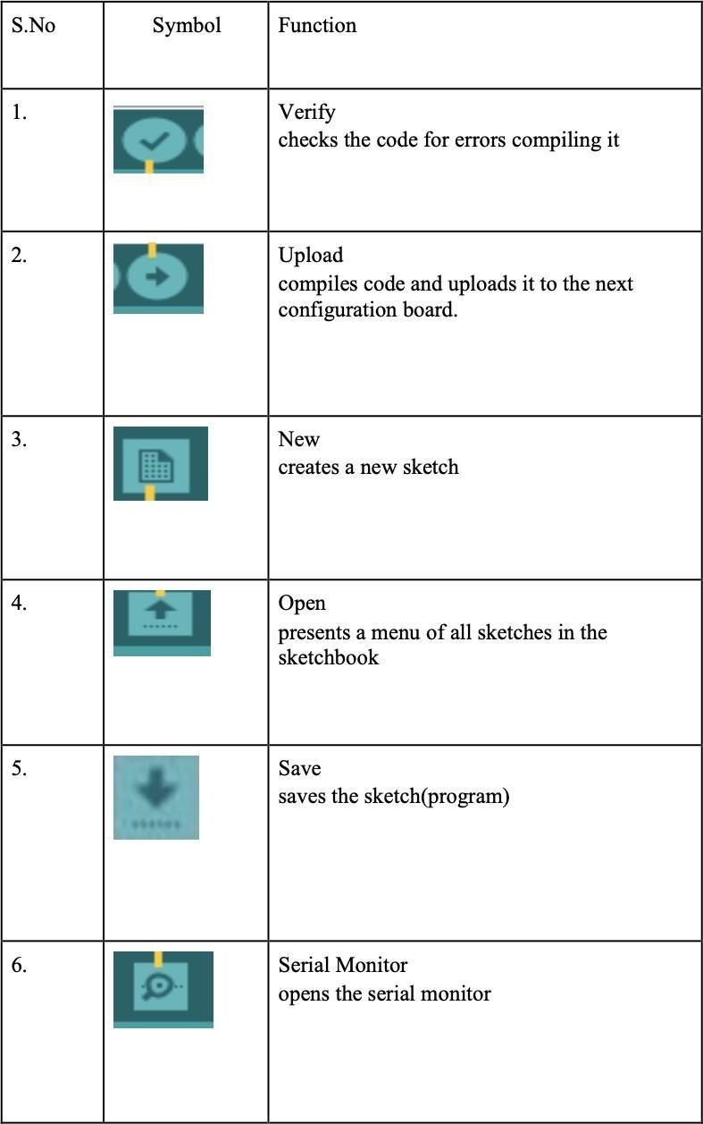

## **5.WORKING**

The system comprises vital components including a Power Supply to drive operations. An LCD screen displays crucial data on the pregnant woman's health. Sensors such as the Heart Beat Sensor and DS18B20 monitor heart rate and body temperature respectively. The Arduino Uno gathers sensor data, transmitting it via the ESP8266 module to the healthcare provider's server for analysis. Additionally, features like the Buzzer, Panic Button, Vibration Sensor, and Voice Chip enhance safety and communication, ensuring timely responses to emergencies.

● **Power Supply:** Provides power to the other components of the system. The power supply provides the necessary electrical power to the entire system. It can be a battery or a mains power supply, ensuring continuous operation.

● **16*2 LCD:** A display that shows the pregnant woman's vital signs and other information. The LCD display provides real-time feedback to the pregnant woman about her health parameters such as heart rate, body temperature, and any alerts or messages from the system.

● **Heart Beat Sensor:** A sensor that measures the pregnant woman's heart rate. This sensor monitors the pregnant woman's heart rate continuously. It typically employs photoplethysmography (PPG) to detect changes in blood volume in the microvascular tissue.

● **DS18B20:** A temperature sensor that measures the pregnant woman's body temperature. This sensor measures the body temperature of the pregnant woman. It's a digital temperature sensor with high accuracy and can interface with the microcontroller easily.

● **Arduino Uno:** A micro controller that collects the data from the sensors and transmits it to the ESP8266. The Arduino Uno acts as the central processing unit of the system, coordinating the operation of all the sensors and actuators. It collects data from the sensors, processes it, and triggers appropriate actions based on predefined thresholds or conditions.

● **ESP8266:** A Wi-Fi module that transmits the data collected by the Arduino Uno to the healthcare provider's server. The ESP8266 is a Wi-Fi module that enables the system to connect to the internet. It allows data transmission from the monitoring system to a central server or a smartphone application for remote monitoring.

● **Buzzer:** A device that produces an audible alarm if the pregnant woman's vital signs are outside of the normal range. The buzzer is an auditory indicator used to alert the pregnant woman in case of emergencies or abnormal health readings.

● **Panic Button:** A button that the pregnant woman can press to call for help. The panic button allows the pregnant woman to trigger an emergency alert manually. It's a quick way to call for help if she feels unwell or encounters any problems.

●**Vibration Sensor**: Vibration sensors detect any unusual movements or vibrations that might indicate a fall or an accident. A vibration sensor is like a tiny alarm system that feels movement.

the system can alert someone to come and help. It's like having a little guardian watching out for you in case of accidents.

●**Voice Chip and Speaker**: These components can be used to deliver spoken alerts or instructions to the pregnant woman. In case of an emergency.

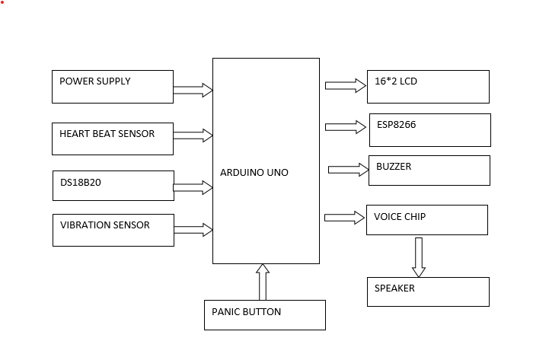

Fig.5.1 Block Diagram

The system works as follows:

1. The pregnant woman wears the heart rate sensor and temperature sensor to continuously monitor her vital signs. continuous monitoring of vital signs, including heart rate and temperature, plays a vital role in ensuring the health and well-being of pregnant women. By detecting abnormalities early and facilitating timely interventions, wearable sensors contribute to safer pregnancies and better outcomes for both mother and baby.
2. The Arduino Uno gathers data from the sensors, including heart rate from the heartbeat sensor and body temperature from the DS18B20 sensor. This data is then transmitted to the ESP8266 module. facilitating wireless communication. The ESP8266 module acts as a bridge, enabling the transfer of sensor data to other devices or a central monitoring system for further analysis and action. This setup enables remote monitoring of vital signs, enhancing convenience and accessibility in healthcare applications.
3. The ESP8266 module transmits the collected data to the healthcare provider's server via Wi-Fi or internet connection. Upon reaching the server, the data is logged and organized systematically for analysis. Healthcare professionals can access this stored data securely, allowing for remote monitoring and timely intervention if necessary. This process facilitates efficient tracking of patients' vital signs and enables proactive healthcare management.
4. Healthcare providers regularly review the data to monitor the pregnant woman's health condition. Based on the Analysis of the data informs decisions regarding necessary interventions and adjustments to care plans. By closely monitoring vital signs and trends, healthcare professionals can provide timely support and interventions to optimize maternal and fetal well-being throughout the pregnancy. This proactive approach helps mitigate potential risks and ensures comprehensive care for both the mother and the baby.
5. If the pregnant woman's vital signs deviate from the normal range, the system activates a buzzer to alert her and healthcare providers. Simultaneously, the LCD display may present warning messages, offering visual feedback on the detected abnormality. This dual notification system ensures immediate awareness and facilitates prompt intervention to address potential health concerns during pregnancy. Such alerts enhance safety measures and support timely responses to deviations from expected vital sign parameters.
6. In case of emergencies or requiring immediate aid, the pregnant woman can activate the panic button. This action triggers an alert sent directly to the healthcare provider, signaling the urgent need for intervention or assistance. Such a feature ensures swift responses to critical situations, facilitating timely medical attention and support during emergencies in pregnancy. The panic button serves as a crucial safety measure, offering reassurance and prompt assistance when required.
7. The system integrates a vibration sensor to detect abrupt movements or falls. Upon sensing unusual vibrations, the sensor activates an alert mechanism to enhance the safety monitoring of the pregnant woman. This feature provides an additional layer of protection by promptly notifying healthcare providers or caregivers of potential accidents or emergencies. The vibration sensor serves to mitigate risks and ensure proactive response to unforeseen events, promoting the well-being and safety of the pregnant woman.
8. A voice chip and speaker are included in The system incorporates a voice chip and speaker to enhance communication capabilities. During critical situations, the voice chip can deliver spoken alerts or instructions to the pregnant woman or caregivers. This feature ensures clear and immediate communication, facilitating prompt responses to emergencies or important notifications. By providing auditory cues, the voice chip enhances accessibility and effectiveness in conveying vital information, contributing to the overall safety and well-being of the pregnant woman.

In a telemonitoring system designed for high-risk pregnant women, vital signs are continuously monitored using specialized sensors. The heart rate monitor tracks the mother's heartbeat, while the DS18B20 sensor records her body temperature. Additionally, a vibration sensor is integrated to detect sudden movements or falls, promptly triggering alerts for immediate assistance. Data from these sensors is transmitted and displayed in real-time on a 16x2 LCD screen, offering immediate feedback to both the pregnant woman and her caregivers. This comprehensive system ensures timely detection of any abnormalities or emergencies, facilitating proactive intervention and enhancing the safety and well-being of both the mother and the baby.

The ESP8266 module facilitates internet connectivity, enabling remote monitoring and transmission of vital data to healthcare professionals, ensuring timely intervention. A buzzer offers audible alerts during emergencies, reinforced by a voice chip and speaker for clear verbal instructions or alerts. Additionally, a panic button empowers the woman to summon immediate assistance if required. Serving as the central hub, the Arduino Uno orchestrates the operation of all system components seamlessly. This integrated setup aims to deliver proactive and personalized care, continuously monitoring the pregnancy to enhance maternal and fetal outcomes. By leveraging advanced technology, the system aims to optimize healthcare delivery, ensuring the safety and well-being of both the pregnant woman and her baby.

**Patient Enrollment and Data Collection:** Patient enrollment and data collection serve as foundational elements in telemonitoring systems for high-risk pregnant women, ensuring personalized and effective monitoring throughout the pregnancy journey. The process begins with the enrollment of high-risk pregnant women into the telemonitoring program, wherein comprehensive patient data is gathered, including medical history, current health status, and specific risk factors associated with the pregnancy. This information provides healthcare providers with valuable insights into the patient's health condition and helps tailor monitoring plans to address individual needs and concerns.

Enrolling patients into the telemonitoring program involves the development of personalized monitoring plans based on the collected data. These plans typically incorporate various sensors, such as heart rate monitors, DS18B20 temperature sensors, and panic buttons, into wearable devices worn by the pregnant women. These devices enable continuous data collection, allowing healthcare providers to monitor vital signs and detect any abnormalities or deviations from normal parameters in real-time.

The incorporation of wearable devices equipped with sensors facilitates seamless and non-intrusive monitoring, empowering high-risk pregnant women to actively participate in their care while ensuring continuous data collection. These devices play a crucial role in monitoring key health indicators such as heart rate, body temperature, and movement, providing healthcare providers with a comprehensive overview of the patient's health status.

**Device Integration:** Device integration in telemonitoring for high-risk pregnant women involves the seamless assimilation and coordination of various monitoring devices and technologies within a centralized system, such as a Central Monitoring System (CMS). The objective is to establish a unified and interoperable environment where data from diverse devices can be efficiently collected, aggregated, and analyzed in a cohesive manner, facilitating comprehensive health monitoring. Enrolled individuals are provided with wearable devices or home monitoring kits equipped with sensors tailored to monitor critical health indicators such as blood pressure, heart rate, blood glucose levels, and fetal heart rate. The selection of parameters is based on the identified risks and individual needs of the patient, ensuring personalized and targeted monitoring. These devices are strategically chosen to address specific concerns and provide a comprehensive overview of the patient's health status. Through device integration, data from different sources can be seamlessly integrated and analyzed within the centralized system, enabling healthcare providers to gain valuable insights into the patient's health condition. This integrated approach enhances the efficiency and effectiveness of telemonitoring initiatives, facilitating early detection of potential issues and timely intervention to optimize health outcomes for high-risk pregnant women. By leveraging advanced technologies and tailored monitoring solutions, device integration supports a holistic approach to prenatal care, empowering patients and healthcare providers alike in managing high-risk pregnancies.

**Real-Time Data Transmission:** Real-time data transmission is a critical component of telemonitoring for high-risk pregnant women, enabling instantaneous transfer of health-related information from wearable monitoring devices to a centralized system, typically a Central Monitoring System (CMS).

This continuous transmission allows healthcare providers to monitor the health status of pregnant women in real-time, facilitating prompt intervention in case of potential issues or deviations from normal health parameters.

The collected data from sensors like heart rate monitors and DS18B20 temperature sensors is transmitted in real-time to the centralized monitoring system. This system is often cloud-based, ensuring seamless and secure data transmission, thus maintaining the integrity and confidentiality of patient information.

Wireless technologies such as Bluetooth or internet connectivity are commonly utilized to facilitate the continuous flow of information from the wearable devices to the centralized system. These technologies enable instantaneous data transfer, ensuring that healthcare providers have access to up-to-date information about the patient's health status.

The use of real-time data transmission enhances the effectiveness of telemonitoring for high-risk pregnant women by providing healthcare providers with timely and accurate information. This allows for proactive monitoring and intervention, ultimately leading to better health outcomes for both the mother and the baby.

**Central Monitoring System:** A Central Monitoring System (CMS) plays a pivotal role in telemonitoring for high-risk pregnant women, serving as the centralized platform for data aggregation, analysis, and management. This infrastructure facilitates seamless integration of health data collected from remote monitoring devices, such as heart rate sensors and DS18B20 temperature sensors, providing healthcare professionals with real-time access to crucial information.

At the heart of the telemonitoring system, the CMS employs advanced algorithms and decision support systems to analyze incoming data. These algorithms compare the gathered data against established norms, enabling the early detection of potential issues or deviations from expected parameters.

The CMS serves as a hub for healthcare professionals, allowing them to monitor the health status of pregnant women remotely and intervene promptly when necessary. By providing a comprehensive overview of the patient's health data, the CMS enables coordinated care and timely interventions to address emerging concerns.

Through automated analysis and alert systems integrated into the CMS, healthcare providers can identify abnormalities or concerning patterns in the data. This early detection capability facilitates proactive intervention strategies, helping to mitigate risks and optimize health outcomes for both the mother and the baby.

**Alerts and Notifications:** Alerts and notifications play a crucial role in facilitating timely intervention and safeguarding the health and well-being of both the mother and the baby. These alerts are triggered based on real-time analysis of data collected from monitoring devices, promptly identifying any deviations from normal parameters or signs of potential complications.

When abnormalities or deviations are detected, the system generates alerts to notify healthcare providers promptly. These alerts are communicated through various channels, including secure portals, mobile apps, or designated communication channels, ensuring healthcare professionals can respond swiftly to emerging concerns.

Sensors like heart rate monitors and vibration sensors contribute to the generation of alerts, signaling any deviations from normal parameters or indications of potential issues. These alerts are transmitted through devices such as buzzers and voice chips, providing immediate notification to healthcare providers for swift intervention.

The real-time nature of this notification system enables healthcare professionals to act promptly, addressing potential complications or concerns before they escalate. By leveraging advanced technology and continuous monitoring, the telemonitoring system enhances the ability of healthcare providers to deliver proactive and personalized care to high-risk pregnant women.

**Healthcare Provider Intervention:** healthcare provider intervention is a critical component aimed at utilizing data collected from remote monitoring to ensure optimal health outcomes for both the mother and the baby. When alerts are generated by sensors like heart rate monitors and vibration sensors, healthcare providers can remotely intervene promptly. This intervention may involve adjusting medication regimens, prescribing additional tests, or scheduling in-person visits as necessary.

Remote interventions are particularly crucial in managing high-risk pregnancies as they enable healthcare providers to detect potential issues early and provide timely guidance and support. By closely monitoring vital signs and trends through remote monitoring, healthcare professionals can identify deviations from normal parameters and intervene proactively to prevent complications.

The ability to intervene remotely allows healthcare providers to address emerging concerns promptly, minimizing the risk of adverse outcomes. Adjusting medication regimens based on real-time data ensures that pregnant women receive the appropriate treatment tailored to their individual needs.

In addition to medication adjustments, healthcare providers may also recommend lifestyle modifications or provide educational resources to promote healthy behaviors and mitigate risks associated with high-risk pregnancies.

Furthermore, scheduling in-person visits when necessary ensures that pregnant women receive comprehensive care and thorough evaluations when remote monitoring alone may not suffice. These in-person visits allow for hands-on assessments and further diagnostic tests, if required, to address any identified concerns effectively.

**Patient Engagement and Education:** Patient engagement and education are integral components of telemonitoring systems for high-risk pregnant women, fostering empowerment and improving health outcomes. These systems offer feedback on health data via devices like 16*2 LCD displays and speakers, facilitating real-time communication and guidance. Educational resources provided through these systems empower patients to make informed decisions about lifestyle modifications, medication adherence, and self-care practices. By actively involving patients in their care, telemonitoring systems promote a collaborative relationship between healthcare providers and pregnant women. This approach enhances patient satisfaction, adherence to treatment plans, and overall well-being throughout the pregnancy journey. Through continuous engagement and education, patients develop a deeper understanding of their health status and are equipped with the knowledge and tools needed to manage their conditions effectively. Ultimately, patient-centered telemonitoring systems contribute to improved outcomes by encouraging proactive involvement in healthcare decisions and promoting healthier behaviors.

**Remote Consultations:** The system facilitates remote consultations between healthcare providers and patients. Through video conferencing or messaging systems, healthcare professionals can address patient concerns, provide guidance, and answer questions. This virtual interaction reduces the need for frequent in-person visits, especially important for high-risk pregnancies where regular monitoring is essential.

Remote consultation plays a pivotal role in enhancing access to specialized care, particularly beneficial for high-risk pregnant women encountering obstacles in attending frequent in-person appointments. It fosters early detection of potential issues, facilitating timely interventions crucial for improving maternal and fetal outcomes. Through regular communication via virtual channels, a supportive relationship between healthcare providers and pregnant women is established, enriching the pregnancy journey.

The system enables remote consultations by leveraging technologies such as video conferencing and messaging systems. These platforms facilitate seamless communication and ensure timely access to specialized care, catering specifically to the needs of high-risk pregnant women who may face limitations in attending traditional appointments.

By transcending geographical barriers, remote consultations bridge the gap between healthcare providers and patients, enabling comprehensive monitoring and management of pregnancy-related concerns. This approach empowers pregnant women with greater flexibility in accessing healthcare services, promoting a sense of empowerment and control over their health during this critical period.

Through remote consultations, healthcare providers can conduct thorough assessments, offer personalized guidance, and address any emerging issues promptly. This proactive approach significantly contributes to mitigating risks and optimizing health outcomes for both the mother and the baby.

Furthermore, remote consultations facilitate ongoing education and support, empowering pregnant women with valuable information and resources to navigate their pregnancy journey effectively. This continuous engagement fosters a sense of confidence and reassurance, alleviating anxiety and promoting overall well-being.

Overall, the integration of remote consultation into prenatal care represents a significant advancement in healthcare delivery, offering unparalleled accessibility and convenience without compromising the quality of care. By harnessing the potential of technology, healthcare providers can deliver tailored, patient-centered services that prioritize the safety and welfare of high-risk pregnant women and their unborn children, ultimately leading to healthier outcomes and positive pregnancy experiences.

# **6.RESULTS**

The implementation of a telemonitoring system for high-risk pregnant women has generated a buzz in the healthcare community due to its promising results. By enabling remote monitoring and timely intervention, the system has shown significant improvements in maternal and fetal health outcomes, leading to increased patient satisfaction and reduced healthcare costs. Its success suggests a potential paradigm shift in prenatal care delivery, with the integration of technology to provide personalized management for high-risk pregnancies. However, ongoing research and evaluation are essential to optimize the system's effectiveness and address any remaining challenges.

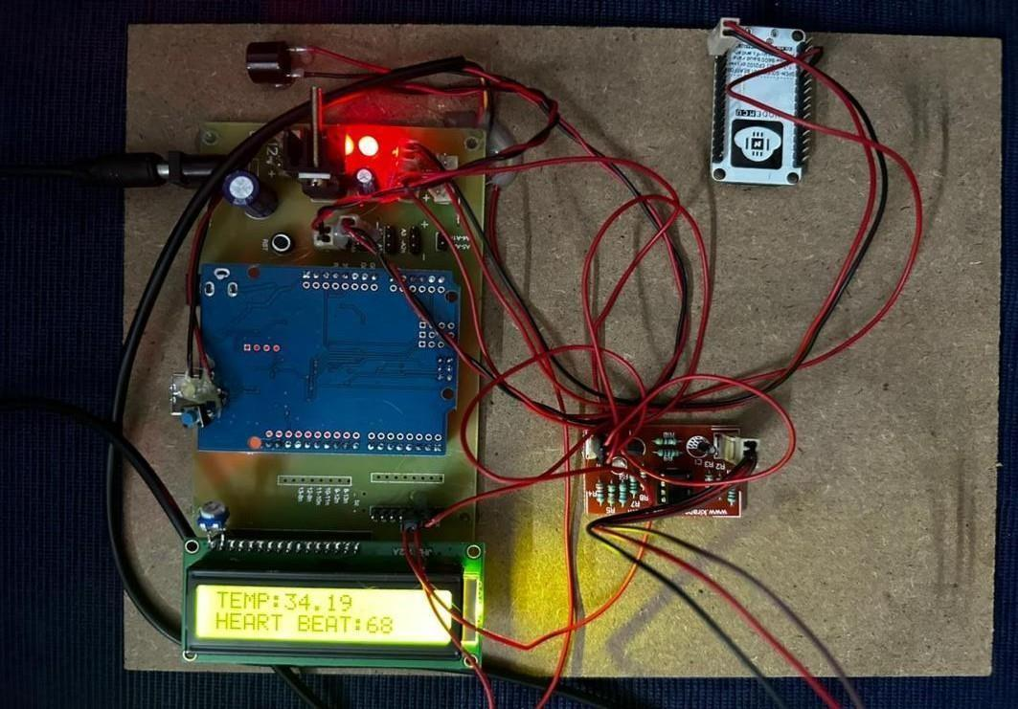

Fig.6.1 LCD displays the values from heart and temperature sensors

1. LCD is used to present information gathered from both a heart sensor (probably measuring heart rate or other cardiac metrics) and a temperature sensor. The integration of sensors and a display allows users or healthcare professionals to easily access and interpret vital information.
2. When the panic button is pressed, it triggers a panic alert, and the relevant information or message is displayed on the LCD. The panic button serves as a quick and direct way for users to signal that they are in distress or need immediate assistance. Once activated, the system responds by displaying a panic alert on the LCD to notify those around or connected to the system that there's an urgent situation.

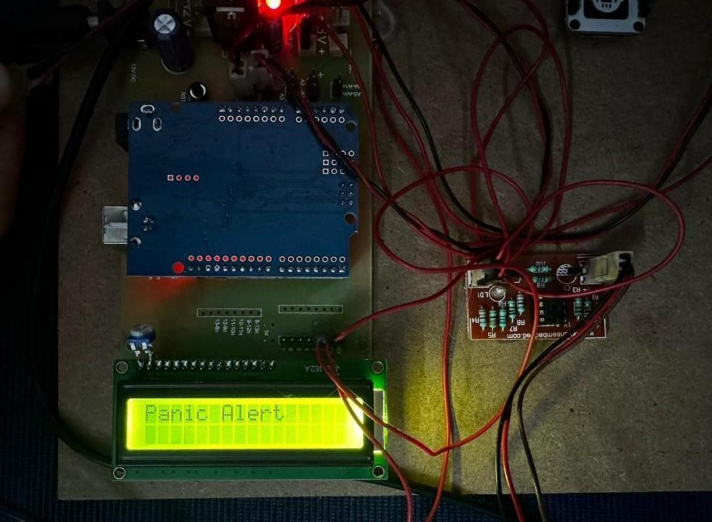

Fig.6.2 Panic alert is displayed on LCD when panic button is pressed

When the microcontroller detects that the panic button has been pressed, it triggers an action to display a panic alert message on the LCD display. This message could be something like "Panic Alert!" or any other message you choose to indicate the emergency situation. After displaying the panic alert message for a certain duration , the microcontroller clears the LCD display to remove the panic alert message. This ensures that the display doesn't remain stuck on the panic alert message indefinitely.

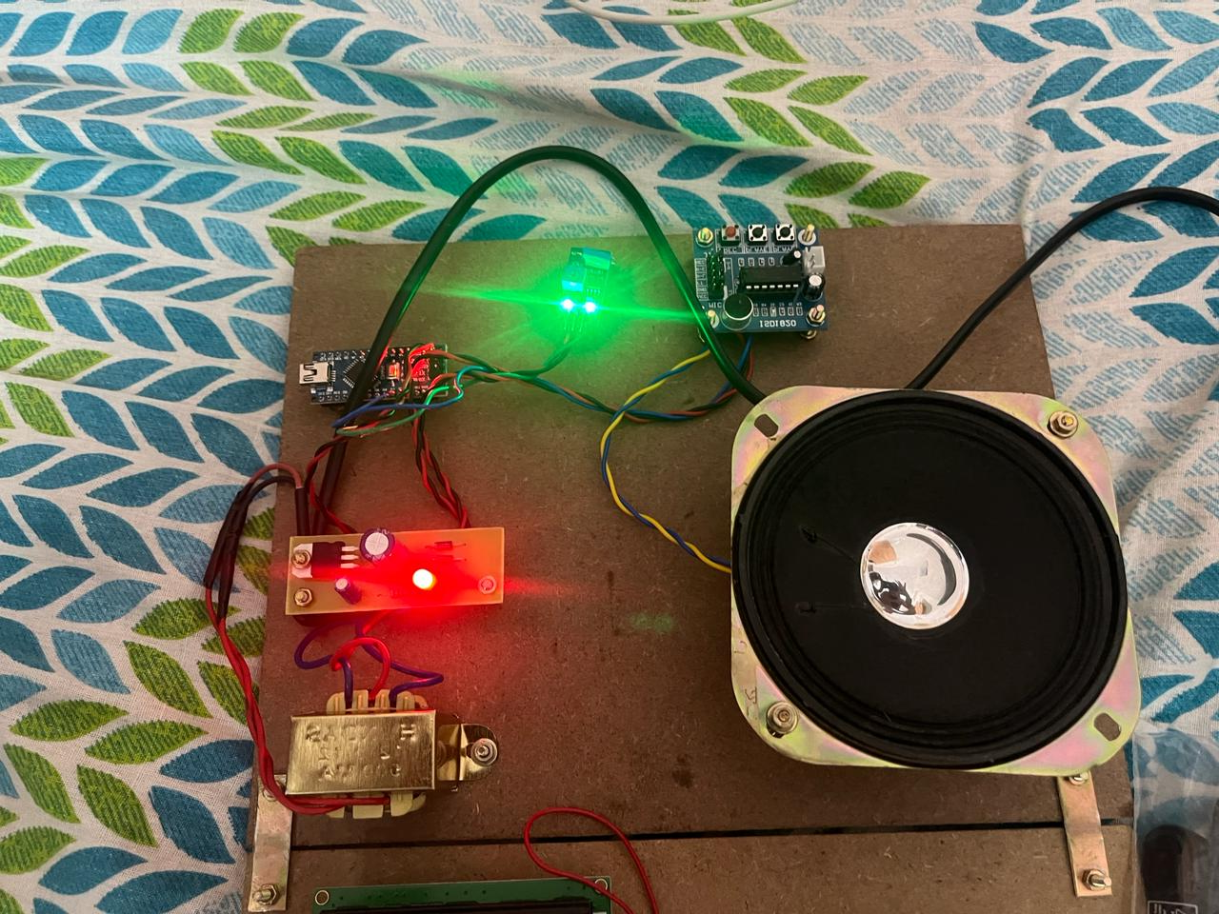

Fig.6.3 Baby movements is displayed through voice chip

These devices use ultrasound technology to detect and monitor the baby's heartbeat and movements. While they typically display the heartbeat as an audible sound, some models also feature a visual display or strip that corresponds to the baby's movements, providing a graphical representation of the fetal activity alongside the audio output. This visual representation can help healthcare providers and expectant parents better understand the baby's movements and assess its well-being during pregnancy.

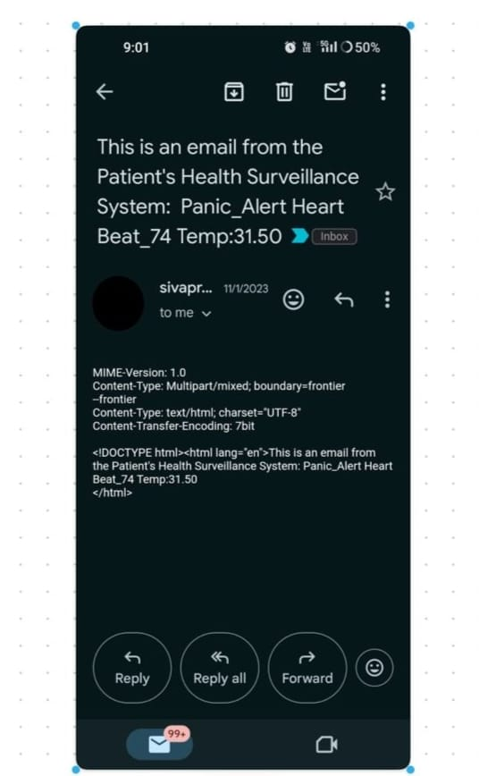

Fig.6.4 Output received through mail which displays the health condition

Telemonitoring of high-risk pregnant women involves remotely monitoring their health condition through various means, including receiving results via mail. This approach allows healthcare providers to closely track the health status of pregnant women who are at elevated risk for complications, such as preterm labor, gestational diabetes, or hypertension. By receiving test results through mail, healthcare professionals can promptly assess any abnormalities or concerns and provide timely interventions or adjustments to the treatment plan, thus improving maternal and fetal outcomes.

These can include wearable devices such as smartwatches or specialized medical devices that measure parameters like blood pressure, heart rate, fetal heart rate, uterine activity, and glucose levels. These devices continuously monitor vital signs or specific health indicators and transmit the data to a central monitoring system. Health information, including medical history, lab results, and ultrasound reports, is stored electronically in EHR systems. Healthcare providers can access this information remotely to review the patient's health status and track any changes or trends over time.

Telecommunication technologies, such as secure messaging platforms or video conferencing tools, enable communication between healthcare providers and pregnant women. This allows for remote consultations, discussion of test results, and adjustment of treatment plans as needed. Test results, appointment reminders, and educational materials can be sent to pregnant women via mail. While electronic communication is often preferred for its immediacy, mail communication ensures that important information reaches the patient even if they don't have regular access to email or smartphones.

# **7.ADVANTAGES AND DISADVANTAGES**

# **7.1 ADVANTAGES**

* + **Continuous Monitoring:** Offers continuous monitoring of vital signs and health parameters, providing a more comprehensive view of the patient's health status compared to periodic clinic visits.
  + **Remote Consultations:** Facilitates remote consultations with healthcare professionals, allowing timely discussions and adjustments to the care plan without the need for physical presence.
  + **Enhanced Data Accuracy:** Reduces the likelihood of human error in recording and transmitting health data, leading to more accurate and reliable information for healthcare providers.
  + **Improved Patient Education:** Enables the delivery of educational materials and guidance tailored to the individual's health condition, promoting better understanding and self- management.
  + **Reduced Stress and Travel:** Minimizes the stress and physical strain associated with frequent travel to healthcare facilities, particularly beneficial for women with high-risk pregnancies.
  + **Customized Alerts:** Allows for the customization of alerts and notifications based on specific health parameters, ensuring a rapid response to critical situations.
  + **Remote Fetal Monitoring:** Specifically in pregnancy, telemonitoring systems can include features for remote fetal monitoring, providing valuable insights into the baby's well-being between clinic visits.
  + **Reduced In-Person Visits:** Minimizes the need for frequent hospital or clinic visits, offering convenience and reducing stress, especially for women with limited mobility or those living in remote areas.
  + **Personalized Care:** Enables healthcare providers to tailor interventions and care plans based on real-time data, ensuring a more personalized approach to managing individual health needs.
  + **Empowerment and Peace of Mind:** Empowers women to actively participate in their healthcare, fostering a sense of control and assurance, knowing that their health is continuously monitored.
  + **Improved Accessibility:** Enhances access to healthcare, particularly for those facing geographical or logistical barriers, ensuring they receive timely medical attention without physically traveling to healthcare facilities.
  + **Early Detection of Complications:** Continuous remote monitoring enables early detection of potential complications such as hypertension, gestational diabetes, or fetal distress, allowing for timely intervention and management.
  + **Convenience and Comfort:** Pregnant women can avoid the inconvenience and stress of traveling to healthcare facilities for routine monitoring, particularly in cases where transportation or mobility is challenging.
  + **Early Detection and Intervention:** Telemonitoring enables continuous monitoring of maternal and fetal health parameters, such as blood pressure, heart rate, uterine activity, and fetal movements. Early detection of abnormalities or warning signs allows for prompt intervention, potentially preventing complications and improving pregnancy outcomes.
  + **Remote Access to Specialized Care:** High-risk pregnancies often require specialized monitoring and management by obstetricians, maternal-fetal medicine specialists, or other healthcare professionals. Telemonitoring facilitates remote access to specialized care, regardless of geographical barriers, ensuring that pregnant women receive the expertise they need.
  + **Patient Empowerment and Education:** Telemonitoring systems empower pregnant women to take an active role in their own care by providing access to real-time health data and educational resources. This promotes greater awareness of their health status, fosters self-management skills, and encourages adherence to treatment plans and lifestyle modifications.

## **7.2 DISADVANTAGES**

* + - **Equipment Dependence:** Reliance on monitoring devices may create dependency, and malfunctions or inaccuracies in the equipment could lead to misguided healthcare decisions.
    - **Inadequate Emergency Response:** In emergency situations, telemonitoring may not provide immediate on-site assistance, delaying critical interventions compared to being physically present in a healthcare facility.
    - **Health Inequality:** Unequal access to technology and high-speed internet may exacerbate existing healthcare disparities, leaving certain demographics without the benefits of telemonitoring.
    - **Overemphasis on Data:** The focus on data monitoring might overshadow holistic healthcare, potentially neglecting aspects of a patient's well-being that cannot be captured through remote measurements.
    - **Legal and Ethical Concerns:** There may be legal and ethical considerations related to the remote management of high-risk pregnancies, including issues surrounding informed consent, liability, and standards of care.
    - **Potential for Patient Anxiety:** Continuous monitoring might cause heightened anxiety for some high-risk women, especially if they become overly concerned about fluctuations in monitoring.
    - **Tailored Care Plans:** Telemonitoring allows healthcare providers to tailor care plans based on real-time data and individual risk factors. By monitoring specific parameters relevant to each woman's condition, such as blood pressure, glucose levels, or fetal heart rate, care plans can be personalized to address the unique needs and challenges of each pregnancy.
    - **Remote Consultations:** Telemonitoring enables remote consultations between pregnant women and healthcare providers, reducing the need for in-person visits while still allowing for meaningful interactions. These virtual consultations can address concerns, provide guidance on managing symptoms or complications, and offer support and counseling, enhancing the overall patient experience.
    - **Support for Home Births**: For women opting for home births or alternative birthing environments, telemonitoring provides a way to ensure safety and continuity of care. Remote monitoring of maternal and fetal parameters allows healthcare providers to assess the progress of labor, provide guidance to birthing attendants, and intervene if necessary, promoting safe outcomes for both mother and baby.
    - **Data-driven Decision Making:** Telemonitoring generates a wealth of data on maternal and fetal health parameters, which can be analyzed to identify trends, predict outcomes, and guide clinical decision-making. By leveraging data analytics and machine learning algorithms, telemonitoring systems can help healthcare providers detect subtle changes in health status and intervene proactively to prevent complications.
    - **Remote Patient Monitoring:** Telemonitoring extends beyond the prenatal period to encompass postpartum care and monitoring of maternal and neonatal health following childbirth. Remote monitoring allows healthcare providers to continue monitoring vital signs, recovery progress, and breastfeeding success remotely, facilitating early detection of postpartum complications and timely interventions as needed.
    - **Enhanced Communication and Collaboration:** Telemonitoring fosters collaboration and communication among multidisciplinary healthcare teams involved in the care of high-risk pregnant women. By enabling secure messaging, shared access to health records, and virtual care coordination, telemonitoring systems facilitate seamless information exchange and collaborative decision-making, leading to more integrated and holistic care delivery.
    - **Reduced Hospital Readmissions:** Telemonitoring can help reduce the risk of hospital readmissions following childbirth by enabling remote monitoring of postpartum recovery and early detection of complications. By providing ongoing support and follow-up care in the home setting, telemonitoring contributes to smoother transitions from hospital to home and reduces the burden on healthcare facilities

# **8. CONCLUSION AND FUTURE SCOPE**

## **CONCLUSION**

In conclusion, while telemonitoring systems offer a varied of benefits for high-risk women, such as timely detection of health issues, convenient remote monitoring, and improved accessibility to healthcare, there are notable disadvantages that must be carefully considered. The potential loss of human touch, technological barriers, and concerns related to privacy and data accuracy present challenges that demand thoughtful solutions. Additionally, the initial costs of implementation and ongoing regulatory challenges underscore the complexities involved in integrating telemonitoring into high-risk pregnancy care. Striking a balance between the advantages and disadvantages necessitates a nuanced approach, ensuring that the adoption of telemonitoring systems enhances the overall quality of care for high-risk women without compromising essential aspects of patient well-being, privacy, and the traditional healthcare model. Continuous advancements, regulatory frameworks, and an emphasis on patient-centered care will be crucial in realizing the full potential of telemonitoring in supporting the health of high- risk women. Benefits in improving maternal and fetal health outcomes, enhancing patient satisfaction, and reducing healthcare costs through remote monitoring and timely intervention. Additionally, it could emphasize the potential for broader implementation and integration into routine prenatal care to provide continuous support and personalized management for high-risk pregnancies.

# **8.2 FUTURE SCOPE**

The future scope of telemonitoring for high-risk women holds promising developments that could revolutionize maternal healthcare. Firstly, advancements in wearable technology and remote monitoring devices are likely to lead to more sophisticated and user-friendly solutions. These could include wearable sensors capable of monitoring a broader range of health parameters with increased accuracy, providing a comprehensive and real-time picture of maternal and fetal well-being. Integration with artificial intelligence (AI) and machine learning algorithms may enhance the predictive capabilities of telemonitoring systems, enabling early identification of potential complications and personalized risk assessments.

Moreover, the expansion of telehealth infrastructure and the integration of telemonitoring into routine healthcare practices are expected to become more widespread. This could lead to improved access to specialized care for high-risk women, particularly in geographically remote areas. Collaborations between healthcare providers, technology developers, and policymakers will play a crucial role in establishing robust regulatory frameworks and standards to ensure the ethical and secure implementation of telemonitoring systems.

The future may also witness increased emphasis on patient engagement and empowerment through telemonitoring. Interactive platforms that enable continuous communication between healthcare providers and high-risk women, along with educational resources tailored to individual needs, could contribute to better self-management and informed decision-making. Telepsychiatry services, integrated mental health support, and holistic care approaches may address not only the physical but also the psychological well-being of women facing high-risk pregnancies. Integrate wireless communication modules (like Wi-Fi, Bluetooth, or GSM/GPRS) to send panic alerts to smartphones or centralized monitoring systems. This would enable real-time notifications and remote monitoring of panic situations.